T’other Side o’Bolton Walk

Walk Date: Saturday 15th March 2025

Distance: Long route 9.4m, Short Route 7.2m

Walkers: Team Dave – Christine, Mike W, Dave C, Sarah. (5).

Team Mike - Lesley, Selina, Heather, Clare, Sue, Jo, Anne & Fred, Della,

Lynn & Bruce + Cleo (12)

An 8.15 meet up and an easy journey on the motorway to the outskirts of Bolton, (Bottom o’th Moor) enabled the group to be booted up and ready for a walk start time of 9.30, in **typical Bolton sunshine**! Crossing a main road led us to a track and quickly into open countryside, progressing between lodges (note 1), through a horse pasture and onto a wide track, with the Lancashire plain soon in view.

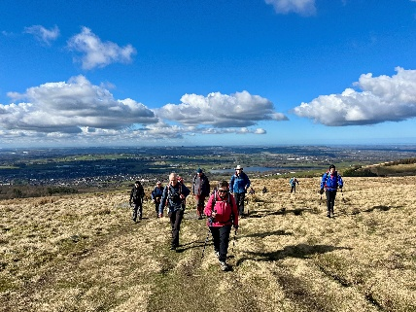Turning right onto a footpath, a short ascent soon led to the twin cairns of Two Lads, believed to be a Bronze Age Burial chamber, with wide views of Lancashire, South Pennines, Cheshire and the Welsh Hills, not forgetting the Toughsheet stadium (home of the famous Bolton Wanderers) a few miles below us. Those with better eyesight could spot Blackpool Tower in the haze.

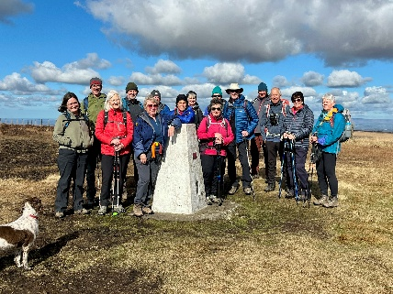

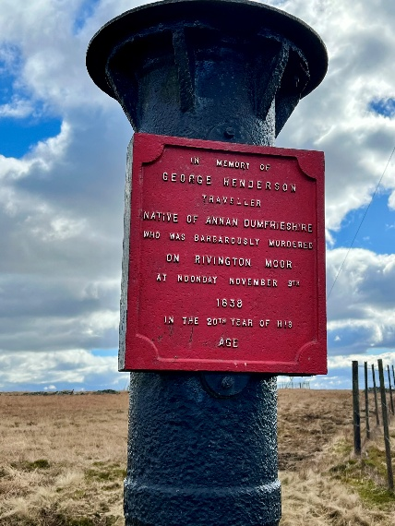The coffee break was taken a short time later, and an easy ascent led to the Trig Point on Winter Hill, (Top o’th Moor?) standing 1498’ above sea level. The views were now to the east with both Peel Monument (above Bury) and Darwen Tower and the Pennines clearly in view. A few para-gliders were trying in vain to get airborne from the top.

The large TV mast on top is 1015’ high, the first transmission was a broadcast on BBC2 transmitting on 31st October 1965, followed by BBC1 and ITV the following year. (bygone days of 3 channel TV!

Amongst several smaller masts lies The Scotsman’s Stump. A murder most brutal!. The killer was never brought to justice. (Note 2)

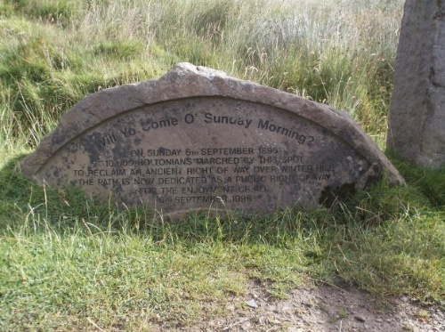Now heading south east from the top, lunch was taken, just before reaching a memorial stone commemorating the Winter Hill mass trespass of 1896. A 4 week long campaign against the land owner’s attempts to remove traditional rights of way across the moor with upward of 12,000 people demonstrating. (The better known Kinder Scout trespass of 1932 in comparison attracted about 400!)

It was now time to part ways, with Mike leading his group around Adam Hill and through part of the recently planted Northern Forest before descending between quarries to reach the cars.

My group opted for the longer option, dropping down to the quaint hamlet of Barrow Bridge, before climbing the ’63 steps’ and back across Burnt Edge and the quarries.

Despite a little congestion on the motorway both groups made it back to the Dysart shortly after 3pm for liquid refreshment,

Thanks to everyone for their company, with a special thanks to Mike.

And congratulations to Dave C who became a grandfather again during the walk!

**And it didn’t rain!!!!!!**

Dave

Note 1 – Lodge – ‘A small body of water usually attached to a mill or bleach works, now often used for fishing’ (northern terminology)

Note 2 – No Scotsmen were harmed in the undertaking of this walk. Bruce survived!